Updated ~2016.

See the [2018 CIS guide](https://drive.google.com/drive/folders/1dooBBewa6HRA85a4KsA4XH3fhIaxckrs) for more details.

**CIS In 500 Words**

This page is intended to serve as the quick(er) review of the work you’ll be responsible for while you are a CIS tech. This job is a mixed bag! Every year is different and your time here will look different from ours, but it’s a safe bet to expect a reasonable amount of juggling between projects. You can think of your work here as falling into one of **three** categories: Charge Injection System (CIS) calibrations, maintenance, or Tile Cal studies. But first let’s talk a little about Tile Cal!

ATLAS is made up of a bunch of different sub-detectors. These will generally specialize in different things (e.g. there’s a muon chamber for.. well muons). As a CIS tech you are a calibration expert for the Tile Calorimeter. The electronics at the core of the Tile data taking is called a “3in1 card”. There are 10,000 of them down in the experimental cavern and you are responsible for calibrating, studying, and generally knowing what’s up with everything 3in1 related. You are part of a larger group of calibration experts in Tile and operations experts (with some overlap in the two).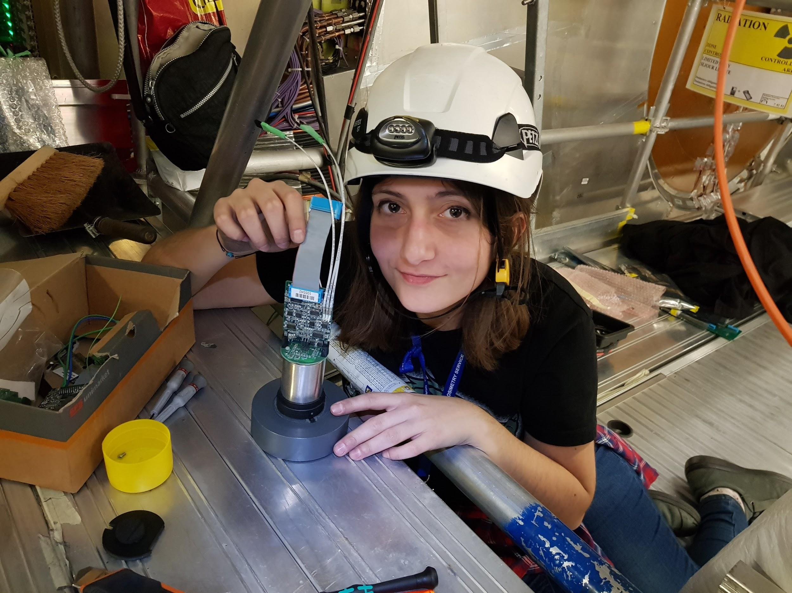

**Calibration** is something that you will do monthly during data-taking periods. You do this because there are 10,000 cards and their status can drift or sometimes abruptly change during the year. How does the calibration work? Well, this process has been going on for about a decade so the system runs pretty smoothly. What you *actually have to do* is execute some well-documented python code. That python code will create a bunch of plots and a database file. You study the plots, make sure there’s not some crazy stuff happening, present the results to a low-key group meeting, and then email the file to the guy who handles the database for Tile.

**Maintenance**is a necessary step after each year of data-taking because things will naturally wear down and break throughout the year. The LHC shuts down in the winter so that this can happen for each detector. When we were here the shutdown was normal length (~2 months). However long shutdowns happen whenever the LHC experiments are gearing up for significant upgrades, so that they have time to make big changes. During a long shutdown, you will likely be down in the experimental cavern a significant portion of the time. It’s hard to say what this looks like, but generally you will spend your days underground, crawling around ATLAS doing whatever Irakli says.

**TileCal Studies** is what you will likely be doing the majority of your time above ground. These studies can be related to the 3in1 cards in ATLAS or they can be related to the new 3in1 cards that are going to be used for the upgrade. Generally the goals of these studies are to characterize the performance of the new 3in1 cards, or to understand how the legacy ones are misbehaving. We’ve left behind some documentation on the studies we’ve been a part of to give you a sense of what you might work on in the future.